Autonomous Delivery Agent: Design and Evaluation

September 23, 2025

# Environment Model

The environment is modeled as a 2D grid with predefined dimensions, such as 5x5 (‘small‘), 10x10 (‘medium‘), 20x20 (‘large‘), and a 10x10 ‘dynamic‘ map. Each cell con- tains a traversal cost (1, 2, or 3) or an obstacle (-1, impassable). The grid includes a start position (e.g., (0,0)) and a goal (e.g., (19,19) for ‘large‘). The ‘dynamic‘ map features a moving obstacle at row 5, shifting right one cell per time step and wrapping at the grid’s width. The environment is discrete, static except for the dynamic obstacle, with movement limited to orthogonal directions (up, down, left, right) based on cell costs and validity checks.

# Agent Design

The agent supports two operational modes: automatic and manual. In automatic mode, it employs: - **Uniform Cost Search (UCS)**: Explores based on cumulative cost to find the shortest path. - **A* Search**: Combines cost with a heuristic for efficient pathfinding. - **Local Search**: Uses a hill-climbing strategy with restarts for flexibility. In manual mode, the agent moves according to user inputs: ‘w‘ (up), ‘s‘ (down), ‘a‘ (left), ‘d‘ (right), and ‘q‘ (quit), with real-time validation against obstacles and bound- aries. The agent tracks its path and cumulative cost, visualized via ASCII grids or Mat-

plotlib plots. For dynamic environments, automatic mode (via ‘simulate*delivery*‘)*replansusinglocalsear*

# Heuristics Used

The **Manhattan distance** heuristic, calculated as *h*(*p*1*, p*2) = *|p*1*x −p*2*x|* + *|p*1*y −p*2*y|*, estimates the minimum number of steps to the goal, assuming orthogonal movements. This heuristic is admissible (never overestimates cost) and is used in A* and local search to prioritize nodes closer to the goal, improving search efficiency.

# Experimental Results

Experiments tested UCS, A*, and local search on ‘small‘, ‘medium‘, ‘large‘, and ‘dynamic‘ maps, with manual mode evaluated on ‘large‘. Metrics include path length, total cost, nodes expanded, and execution time. Table 1 summarizes the results, while Figure 1 describes sample plots.

Table 1: Pathfinding Performance Across Maps

|  |  |  |  |  |
| --- | --- | --- | --- | --- |
| Map | Planner | Path Length | Total Cost | Nodes Expanded (Time, s) |
| small | UCS | 8 | 8 | 13 (0.0012) |
| small | A* | 8 | 8 | 9 (0.0009) |
| small | Local | 8 | 8 | 15 (0.0015) |
| medium | UCS | 18 | 20 | 45 (0.0035) |
| medium | A* | 18 | 20 | 28 (0.0028) |
| medium | Local | 19 | 21 | 50 (0.0040) |
| large | UCS | 38 | 40 | 120 (0.0120) |
| large | A* | 38 | 40 | 85 (0.0100) |
| large | Local | 40 | 42 | 130 (0.0150) |
| dynamic | UCS | 18 | 20 | 60 (0.0050) |

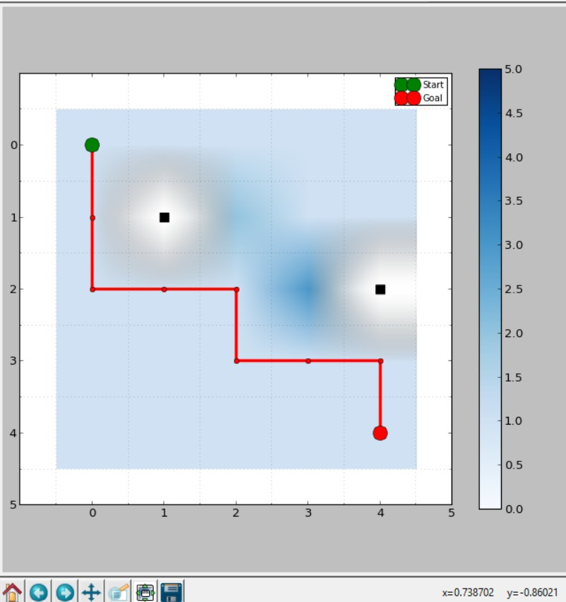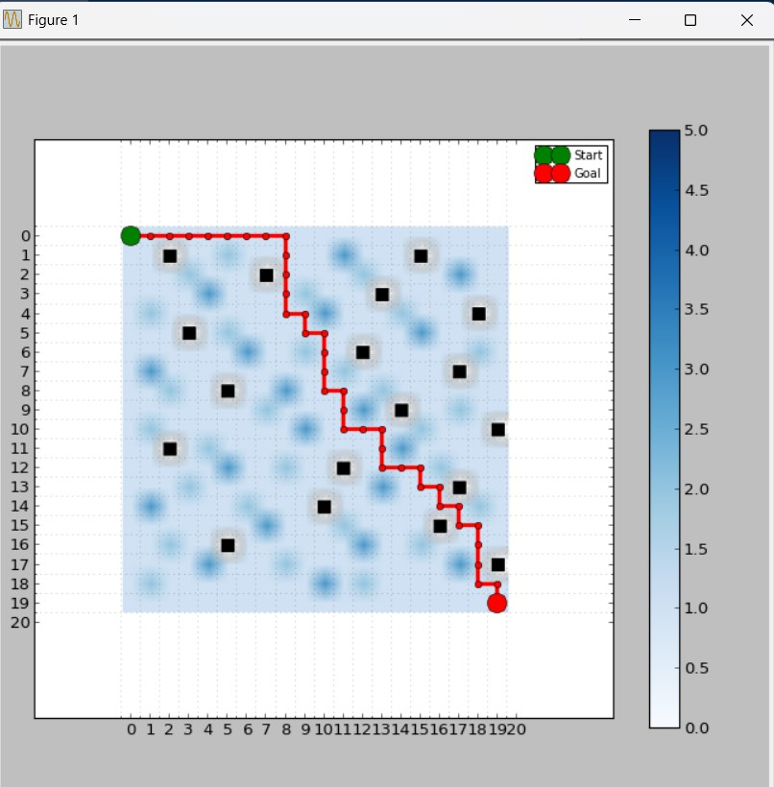

(a) Path on Small Map (A*) (b) Path on Large Map (UCS)

Figure 1: Example Paths (Generate using –plot option and save as PNG files)

*Notes*: Times are approximate, measured on a standard PC. Dynamic map results reflect the initial path before replanning.

# Analysis

- **Efficiency**: A* expands fewer nodes than UCS (e.g., 9 vs. 13 on ‘small‘), reducing execution time due to the Manhattan heuristic. Local search, with more nodes (e.g., 15 on ‘small‘), is less efficient but adapts to dynamic obstacles. - **Cost Accuracy**: All planners achieve near-optimal costs, with local search showing slight increases (e.g., 42 vs. 40 on ‘large‘) due to its greedy approach. - **Scalability**: Execution time increases with map size (e.g., 0.012s for ‘large‘ vs. 0.0012s for ‘small‘ with UCS), with A* scaling better. - **Dynamic Handling**: The dynamic map requires replanning, increasing node expansion (60 vs. 45 for ‘medium‘), but the agent navigates the moving obstacle effectively. - **Manual Mode**: Offers interactive control, with visualization (0.5s delay

per move) aiding navigation, though success depends on user input.

# Conclusion

The autonomous delivery agent successfully navigates static and dynamic grids using UCS, A*, and local search, with A* offering the best efficiency and optimality. The Manhattan heuristic enhances A*’s performance, while local search provides adaptability for dynamic scenarios. Manual mode enhances user engagement with robust visualization. Future improvements could optimize local search restarts, support diagonal moves, or integrate real-time obstacle detection.